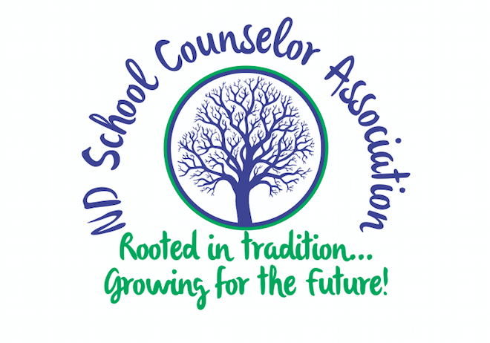
North Dakota School Counseling Association

Essay Contest Form 2019-2020 School Year
(for High School Seniors Graduating in 2020)

Name of Student: ____________________________________________________________________________________
Mailing Address: _____________________________________________________________________________________
City, State, Zip: _______________________________________________________________________________________
Student Email Address: _____________________________________________________________________________
School of student: ____________________________________________________________________________________
School Counselor Signature: _________________________________________________________________________
(Counselor: Your signature verifies that you are a current member of NDSCA in good standing.)
College you plan to attend: __________________________________________________________________________
Parent’s Signature: __________________________________________________________________________________
Parent’s signature is required to permit the use of their child’s essay for publishing in local newspapers and/or North Dakota School Counseling publications. Also, parental permission allows the use of the essay for informing local patrons, school board members and legislators.
Award Amount: $1,000
Please attach the following:
- An essay (500 words or less) describing your career plan and who/what helped you with your decision.
- 1 letter of recommendation
Essays will be scored according to:
- Specific supporting details
- Uniqueness of experience arriving at your career plan
- Impact of experience on student’s life [person/people or event(s)]
- Technical merit (correct use of grammar, spelling, and punctuation)
Deadline:
- Applications must be postmarked by December 18, 2019.
- Send applications to: Vanessa Kocka
Valley City Public Schools
460 Central Ave N
Valley City, ND 58072

